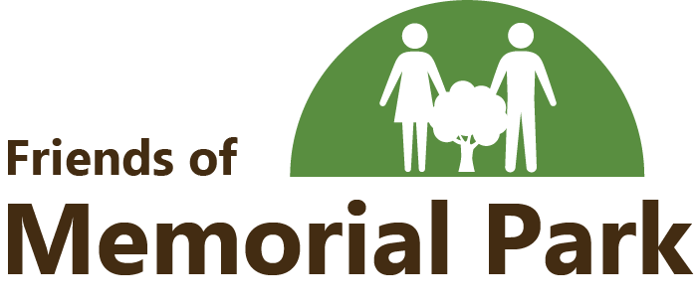

Friends of Memorial Park is a non-profit organization providing financial assistance to subsidize governmental funding. Our goal is to promote public interest in Memorial Park’s historic, educational, cultural, recreational and natural assets. We are organized exclusively for charitable purposes to assist in sustaining Memorial Park as a community asset. Our organization is dedicated to the process of making the Park a better place for you, your family and our community.
Many business and community leaders are excited to help Memorial Park discover all of its potential. You can be a part of this excitement by showing your support with a donation. Monetary
Donations can be given in the amount of your choice or by purchasing a membership.
Annual Young Friends (18 under) $5.00
Annual Individual $10.00
Annual Family/Household $25.00
Lifetime $500.00
Business $100, $250, $500
Corporate $1,500, $2,500, $5,000
Becoming a member of Friends of Memorial Park allows you to make a tax-deductible donation as we are a non-profit 501c3 organization, Tax ID #82-0940304. Receipts and memberships cards will be mailed.
We would like to thank you for your consideration. If you have any questions please feel free to contact us by email at friendsofmemorialpark17@gmail.com. Our website can be found at www.friendsofmemorialpark.com.

Thank you,
Friends of Memorial Park
Board of Directors
Summer Gibson Kaylee Vanetta Joyce Jester Carla Guffey Sonja Conley
Lindsay Posey Open Position Rick Holder Nancy Dietz

Complete the form below and return with your membership or one time donation to:
Friends of Memorial Park
5596 N County Road 550 E
Mooreland, IN 47360
Name: ____________________________ Amount Enclosed: ________________________
Address: ____________________________
____________________________

Contact #: ____________________________
Email: ____________________________
Membership Type: ________________________

